Original Article
Manuscript title here
(also in manuscript) manuscript manuscript
Nguyen Van Xxx¹, Le Hoang Yyyy^{1,2,}∗, Pham Duc Zzzz², Vu Thi Tttt¹
¹Faculty of ...., VNU University of Science, 334 Nguyen Trai, Hanoi, Vietnam
²VNU Central Institute for Natural Resources and Environmental Studies,
19 Le Thanh Tong, Hanoi, Vietnam
Received 9 May 2019
Revised 12 July 2019; Accepted 9 August 2019

Abstract: The Abstract of manuscript. The abstract of manuscript the abstract of manuscript. The abstract of manuscript the abstract of manuscript. The abstract of manuscript the abstract of manuscript. The abstract of manuscript the abstract of manuscript. The abstract of manuscript the abstract of manuscript. The abstract of manuscript the abstract of manuscript. The abstract of manuscript the abstract of manuscript. The abstract of manuscript the abstract of manuscript. The abstract of manuscript the abstract of manuscript. The abstract of manuscript the abstract of manuscript. The abstract of manuscript the abstract of manuscript. The abstract of manuscript the abstract of manuscript. The abstract of manuscript the abstract of manuscript. The abstract of manuscript the abstract of manuscript. The abstract of manuscript the abstract of manuscript. The abstract of manuscript the abstract of manuscript. The abstract of manuscript the abstract of manuscript. The abstract of manuscript the abstract of manuscript. The abstract of manuscript the abstract of manuscript. The abstract of manuscript the abstract of manuscript. The abstract of manuscript the abstract of manuscript. The abstract of manuscript the abstract of manuscript. The abstract of manuscript the abstract of manuscript. The abstract of manuscript the abstract of manuscript.
Keywords: Keyword_1, Keyword_2, Keyword_3, Keyword_4.

1. Introduction
Doucs (genus Pygathrix) are members of the Old World monkey subfamily Colobinae [1]. This genus contains three species: The Red-shanked Douc (P. nemaeus), Grey-shanked Douc (P. cinerea), and Black-shanked Douc (P. nigripes). The doucs are found only in Indochina and all have limited geographic ranges, and have been threatened with the shrinking of forested habitat areas in their natural distributions [2].
The Red-shanked Douc is only douc species recorded in all three countries of Indochina. The core populations of the Red-shanked Douc now reside in Vietnam and Laos, and it was recently confirmed for northern Cambodia through a genetic analysis [3]. The extent of the species distribution in Cambodia is, however, still in question, and it is likely to be considerably restricted. The douc individuals from Cambodia share many characteristics with those from southernmost Laos [3–5]. The distribution of Pygathrix nemaeus in Vietnam ranges from Pu Mat National Park, Nghe An Province in the North (19°02’N) to the Kon Ha Nung area, Gia Lai Province in the South (14°33’N) [6].
More more more more more more more more more more more ...
Background on Species Distribution Modeling (SDM)
SDM is a relatively new approach that is useful in studying biogeography and evolutionary ecology. It can be used to assess the suitability of distribution range for a taxon, and is become a common approach employed to address conservation issues [13-16]. In general, SDMs use the relationship between observed points of occurrence and influencing variables (termed “environmental variables) to generate a probability map rating the suitability for a species of a given area. SDMs can help to locate areas climatically suitable for a species but have not yet been discovered [13, 17]; to identify cryptic species lineages whose other traits such as morphological characteristics, phylogenic sorting, and reproductive isolation may be incomplete and need more convincing evidences [14]; to design protected areas that accounts for future changes in climate and the distribution of inhabited taxa [18-21]; to determine what environmental variables may contribute most in determining the species’ distribution [22, 23]; and to examine the niche conservatism of ecological traits over evolutionary changes [24,25]. SDMs also play a vital role to answer crucial questions on geographic distributions of species [26]. For instance, in conservation biology and wildlife management, SDMs provide significant information for making informed decisions [27]. This wide range of applications had led to the development of many different SDMs approaches. The accuracy of the predicted results depends on a number of factors, such as the complexity and correlation of the models, the environmental variables and occurrence data inputs [14].
In this paper, we reviewed literature to gather known records of the Red-shanked Douc in Vietnam. We then incorporated distribution data into SDM to generate a distribution map of the species using a maximum entropy approach (Maxent), to help advance understanding and conservation measures for this endangered and keystone species.
2. Methods
Data pre-processing
From the collected records, to avoid spatial autocorrelation, we used the spThin package [28] in R [29] to thin out localities with 10 km distance [14], which resulted in the final set of 51 localities from the original 62 records (Table 1, Fig. 1). We used both results, as well as ecological reasoning to reduce 19 starting variables to 5 variables.
.....
Model Run and Evaluation
We used Maxent software v. 3.4.1 [32, 33] to run the SDM. Unlike many others, Maxent does not require absence records [32], and performs reasonably well even when only a few occurrence records are available [13, 14]. Regularization multiplier was selected by testing a range of values from 0.5 to 10, with a 0.5 increment, and models with the highest area under the curve (AUC) of the receiver-operating characteristic plot were selected. AUC values ranged from 0.5 for models with predictive power no better than random to 1.0 for models giving perfect predictions [34]. This resulted in regularization multiplier equal to 1.5 for subsequent models. Other model parameters (e.g., convergence threshold, and feature selection) followed recommendations from model developers [32].
....
3. Results and discussion
We obtained 62 known records of the Red-shanked Douc based on other peer-reviewed papers, books, and reports (Table 1, Fig. 1).
Table 1. Known distribution records in Vietnam for the Red-shanked Douc
No. | Longitude | Latitude | Record year/duration | Location | References
1 | 104.8 | 19.6 | Until 1988 | Nghe An | [6]
2 | 104.2 | 19.4 | 1995-2002 | Nghe An | [6]
3 | 104.4 | 19.3 | 1995-2002 | Nghe An | [37, 38]
4 | 104.4 | 19.3 | 1989-1994 | Nghe An | [37, 38]
5 | 105.0 | 19.2 | 1989-1994 | Nghe An | [6]
6 | 104.6 | 19.1 | 1989-1994 | Nghe An | [37, 38]
7 | 104.5 | 19.0 | 1989-1994 | Nghe An | [37, 38]
8 | 104.9 | 19.0 | 1989-1994 | Nghe An | [37, 38]
9 | 104.7 | 19.0 | 1995-2002 | Nghe An | [6]
10 | 104.8 | 19.0 | Until 1988 | Nghe An | [6]
11 | 104.9 | 18.8 | 1989-1994 | Nghe An | [37, 38]
12 | 105.5 | 18.5 | Until 1988 | Ha Tinh | [6, 39]
13 | 105.3 | 18.5 | Until 1988 | Ha Tinh | [6, 39]
14 | 105.8 | 18.5 | Until 1988 | Ha Tinh | [6]
61 | 108.6 | 14.4 | 1995-2002 | Gia Lai | [6]
62 | 108.4 | 14.3 | 1995-2002 | Gia Lai | [6]

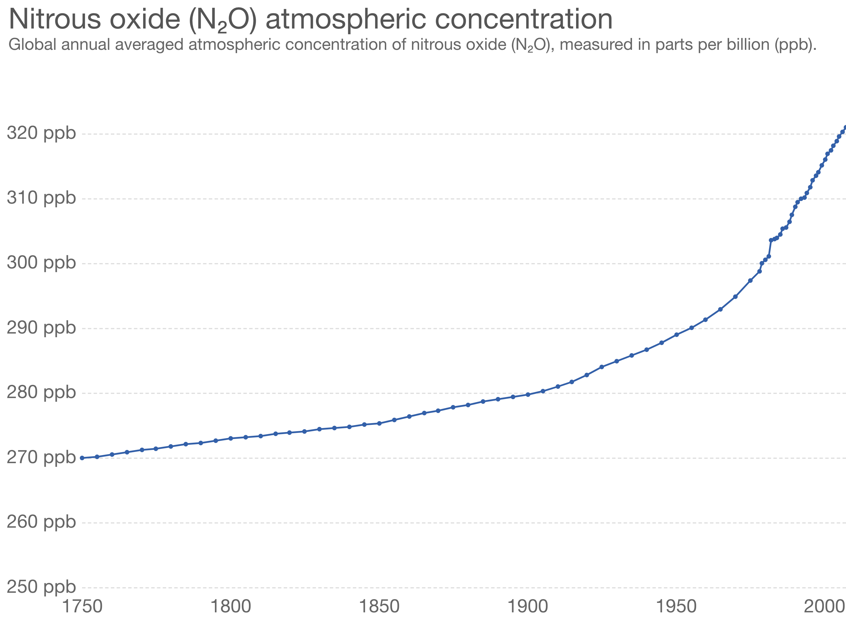
Fig. 1. All 62 collected records of the Red-shanked Douc in Vietnam.

For the SDM, Maxent models showed reasonable prediction power for the distribution of the Red-shanked Douc, with the average AUC values > 0.8. The best model had an AUC value of 0.81. All final SDMs were quite similar in terms of predicting the overall distribution of P. nemaeus and only differed slightly in exact locations and total suitable areas.
According to the model results, the northern limit of distribution range of the Red-shanked Douc appears to fall in the northern part of Nghe An Province, and the southern limit is in Kon Tum region. However, the regularization multiplier value of 1.5 for the best model means that the final model may be prone to under-predicting and over-fitting, which resulted in a fragmented distribution. Also, the equal training sensitivity and specificity threshold, which optimized the predicted area versus the omission error, further reduced the suitable area. The final prediction should therefore be carefully interpreted as “core zones”, or regions that are highly likely suitable for the Red-shanked Douc, rather than potential distribution ranges (Fig. 2). Also, as occurrence records are often more prone to subjective flaws of survey methods at the extremes of distribution range, we suggest that suitable areas at northern and southern limits (i.e., North of Pu Mat National Park and South of Song Thanh Nature Reserve) should be considered with caution.

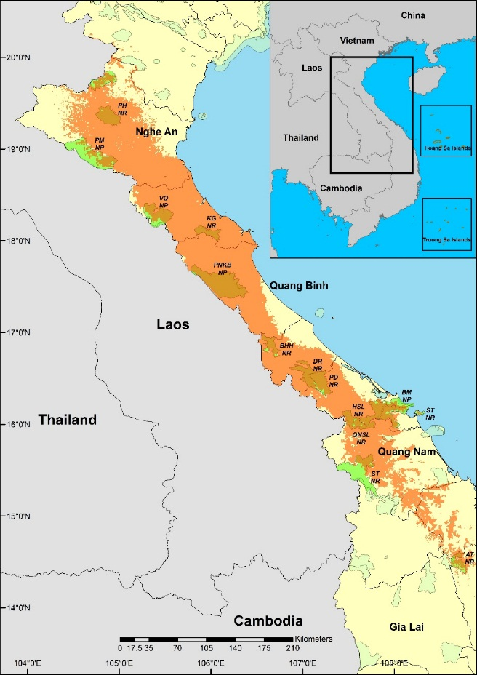
Fig. 2. Species distribution model for the Red-shanked Douc using Maxent. The green areas are protected areas that are in distribution range of the Red-shanked Douc, according to model results. Abbreviation in map from North to South: PH NR – Pu Huong Nature Reserve, PM NP – Pu Mat National Park, VQ NP – Vu Quang National Park, KG NR – Ke Go Nature Reserve, PNKB NP – Phong Nha Ke Bang National Park, BHH NR – Bac Huong Hoa Nature Reserve, DR NR – Dakrong Nature Reserve, PD NR – Phong Dien Nature Reserve, BM NP – Bach Ma National Park, HSL NR – Hue Saola Nature Reserve, ST NR – Son Tra Nature Reserve, QNSL NR-Quang Nam Saola Nature Reserve, ST NR-Song Thanh Nature Reserve, AT NR – An Toan Nature Reserve.

Based on this result, we suggest the following protected areas, which lie within the largely continuous and climatically suitable habitats for the doucs, to be prioritized for more extensive and thorough conservation measures. They include:
According to the SDM results, the species readily inhabit in both side of Hai Van Pass, which plays a major role in dividing climate between North and South Vietnam. Therefore, it may be suggested that bio-climatically speaking, the Red-shanked Douc exhibits characteristics of a generalist species, and consequently, its population more prone to illegal hunting and habitat destruction than changing climate.
Bảng 1. Phân cấp câp độ hạn theo chỉ số ẩm MI
Chỉ số MI | Cấp độ hạn
MI < 0.4 | Nghiêm trọng
0.4 < MI < 0.8 | Nhẹ
0.8 < MI < 1.2 | Đủ ẩm
MI > 1.2 | Thừa ẩm
Acknowledgements
We thank someone someone someone someone someone.
References
[1] K.N. Sterner, R.L. Raaum, Y.P. Zhang, C.B. Stewart, T.R. Disotell, Mitochondrial data support an odd-nosed colobine clade, Molecular Phylogenetics and Evolution 40 (2006) 1–7. https://doi.org/10.1016/j.ympev.2006.01.017.
[2] T.N.E. Gray, A.C. Hughes, W.F. Laurance, B. Long, A.J. Lynam, H. O’Kelly, W.J. Ripple, T. Seng, L. Scotson, N.M. Wilkinson, The wildlife snaring crisis: an insidious and pervasive threat to biodiversity in Southeast Asia, Biodiversity and Conservation 27 (2018) 1031–1037. https:// doi.org/10.1007/s10531-017-1450-5.
[3] B. Rawson, C. Roos, A new primate record for Cambodia : Pygathrix nemaeus, Cambodian Journal of Natural History 1 (2008) 7–11.
[4] R.J. Timmins, J.W. Duckworth, Status and conservation of Douc langurs (Pygathrix nemaeus) in Laos, International Journal of Primatology 20 (1999) 469–489. https://doi.org/ 10.1023/A:1020382421821.
[5] L. Ulibarri, The socioecology of Red-shanked doucs (Pygathrix nemaeus) in Son Tra Nature Reserve, Vietnam, Philosophy of Doctor Dissertation, Department of Anthropology, University of Colorado, Boulder, Colorado, 2013.
[6] T. Nadler, F. Momberg, N.X. Dang, N. Lormee, Vietnam Primate Conservation Status Review 2002. Part 2: Leaf Monkeys, Fauna & Flora International-Asia Pacific Programme, Hanoi, 2003.
[7] V.N. Thanh, L. Lippold, R.J. Timmins, N.M. Ha, Pygathrix nemaeus - The IUCN Red List of Threatened Species 2008: e.T39826A10272920, International Union for Conservation of Nature, Switzerland, 2015.
[8] P. Phiapalath, Distribution, Behavior And Threat Of Red-Shanked Douc Langur Pygathrix Nemaeus In Hin Namno National Protected Area, Khammouane Province, Lao PDR, Philosophy of Doctor Dissertation, Suranaree University of Technology, Thailand, 2009.
[9] C.N.Z. Coudrat, J.W. Duckworth, R.J. Timmins, Distribution and Conservation Status of the Red-Shanked Douc (Pygathrix nemaeus) in Lao PDR: An Update, American Journal of Primatology 74 (2012) 874–889. https://doi.org/10.1002/ajp.22027.
[10] H.H. Covert, H.M. Duc, L.K. Quyet, A. Ang, A. Harrison-Levine, T.V. Bang, Primates of Vietnam: Conservation in a Rapidly Developing Country, Anthropology Now 9 (2018) 27–44. https://doi.org/10.1080/19428200.2017.1337353.
[11] M.E. Blair, E.J. Sterling, M.M. Hurley, Taxonomy and conservation of Vietnam’s primates: A review, American Journal of Primatology 73 (2011) 1093–1106. https:// doi.org/10.1002/ajp.20986.
[12] C.N.Z. Coudrat, C. Nanthavong, K.A.I. Nekaris, Conservation of the red-shanked douc Pygathrix nemaeus in Lao People’s Democratic Republic: Density estimates based on distance sampling and habitat suitability modelling, Oryx 48 (2014) 540–547. https://doi.org/10.1017/S00306053130 00124.
[13] J. Elith, C.H. Graham, R.P. Anderson, M. Dudík, S. Ferrier, A. Guisan, R. J. Hijmans, F. Huettmann, J. R. Leathwick, A. Lehmann, J. Li, L. G. Lohmann, B. A. Loiselle, G. Manion, C. Moritz, M. Nakamura, Y. Nakazawa, J. McC. M. Overton, A. Townsend Peterson, S. J. Phillips, K. Richardson, R. Scachetti-Pereira, R. E. Schapire, J. Soberón, S. Williams, M. S. Wisz, N. E. Zimmermann, Novel methods improve prediction of species’ distributions from occurrence data, Ecography 29 (2006) 129–151. https://doi.org/10.1111/j.2006.0906-7590.04596.x.
[14] R.G. Pearson, C.J. Raxworthy, M. Nakamura, A.T. Peterson, Predicting species distributions from small numbers of occurrence records: A test case using cryptic geckos in Madagascar, Journal of Biogeography 34 (2007) 102–117. https://doi. org/10.1111/j.1365-2699.2006.01594.x.
[15] N.J. Gotelli, J. Stanton-Geddes, Climate change, genetic markers and species distribution modelling, Journal of Biogeography 42 (2015) 1577–1585. https://doi.org/10.1111/jbi.12562.
[16] H. Samejima, E. Meijaard, J.W. Duckworth, S. Yasuma, A.J. Hearn, J. Ross, A. Mohamed, R. Alfred, H. Bernard, R. Boonratana, J.D. Pilgrim, J. Eaton, J.L. Belant, S. Kramer-Schadt, G. Semiadi, A. Wilting, Predicted distribution of the Sunda stink-badger Mydaus javanensis (Mammalia: Carnivora: Mephitidae) on Borneo, Raffles Bulletin of Zoology 2016 (2016) 61–70.
[17] J. Elith, M. Kearney, S. Phillips, The art of modelling range-shifting species, Methods in Ecology and Evolution 1 (2010) 330–342. https://doi.org/10.1111/j.2041-210X.2010.00036.x.
[18] B.A. Bradley, D.S. Wilcove, M. Oppenheimer, Climate change increases risk of plant invasion in the Eastern United States, Biological Invasions 12 (2010) 1855–1872. https://doi.org/10.1007/ s10530-009-9597-y.
[19] J.R. Milanovich, W.E. Peterman, N.P. Nibbelink, J.C. Maerz, Projected loss of a salamander diversity hotspot as a consequence of projected global climate change, PLoS ONE 5 (2010) 1-10. https://doi.org/10.1371/journal.pone.0012189.
[20] P. Kumar, Assessment of impact of climate change on Rhododendrons in Sikkim Himalayas using Maxent modelling: Limitations and challenges, Biodiversity and Conservation 21 (2012) 1251–1266. https://doi.org/10.1007/s10 531-012-0279-1.
[21] R. Khanum, A.S. Mumtaz, S. Kumar, Predicting impacts of climate change on medicinal asclepiads of Pakistan using Maxent modeling, Acta Oecologica 49 (2013) 23–31. https://doi. org/10.1016/j.actao.2013.02.007.
[22] P. Illoldi-Rangel, V. Sanchez-Cordero, A.T. Peterson, Predicting distributions of Mexican mammals, Journal of Mammalogy 85 (2004) 658–662.
[23] P. Chen, E.O. Wiley, K.M. Mcnyset, Ecological niche modeling as a predictive tool: Silver and bighead carps in North America, Biological Invasions 9 (2007) 43–51. https://doi.org/ 10.1007/s10530-006-9004-x.

∗ Corresponding author. E-mail address: abcs@xxx.yyy.vn https://doi.org/10.25073/2588-1094/vnuees.4390

